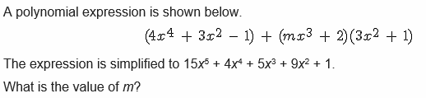

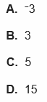

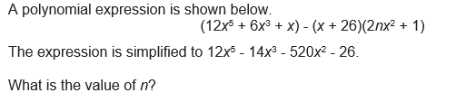



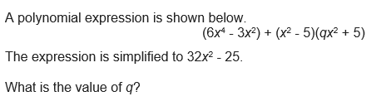



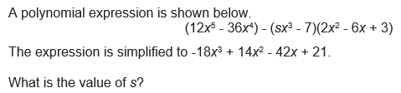



A polynomial expression is shown below.

(ax2 – 5)(3x4 + 2x2 + 6) – (21x6 + 12x3)

The expression is simplified to: -x4 + 12x3 + 32x2 – 30

What is the value of a?

A polynomial expression is shown below.

(-9x6 + 6x2) + (mx3 + 4) (3x6 + 5x3 + 1)

The expression is simplified to: -27x6 + 23x3 + 6x2 + 4

What is the value of m?